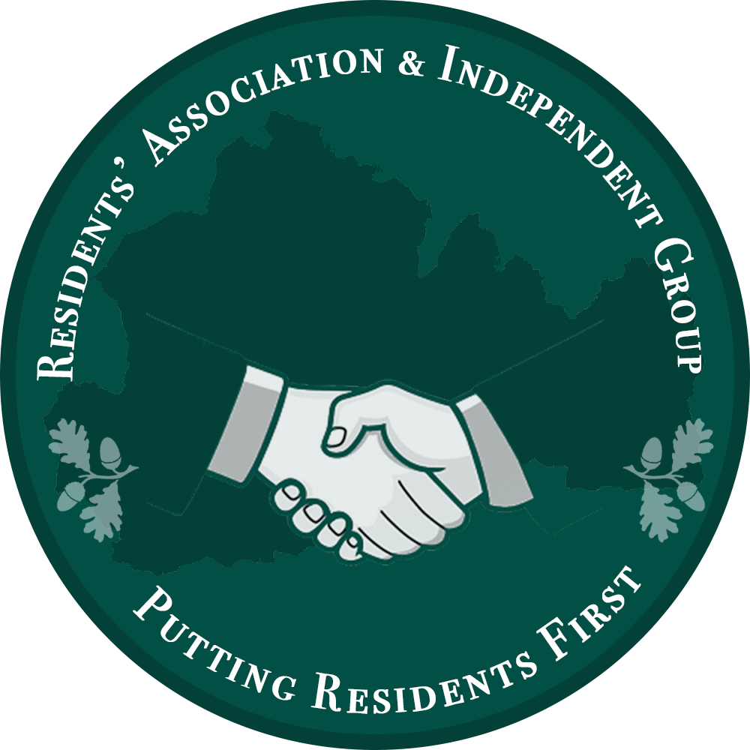

Surrey County Council approves budget cuts of £82m

Residents Association and Independent Councillors warn the Conservative Cabinet that budget cuts will disproportionately affect the most vulnerable

In a desperate effort to make ends meet, the Conservative-lead Surrey County Council voted for a budget that will see thirty-one children’s centres as well as a number of local libraries closing, changes to community recycling centres and other painful measures.

Surrey County Councillor Eber Kington, representing Ewell Court, Auriol and Cuddington was one of the fourteen Councillors who voted against the proposed budget proposal.

“County Councillor Tim Oliver opened the Budget debate suggesting the Budget is less about cuts & more about transforming services. The problem is that cuts are felt now and past SCC transformation schemes have not brought about the promised improvements only further cuts & uncertainty”.

“I could not vote for a SCC Budget that includes a 40% cut in the Epsom & Ewell local highway budget, leaves our streetlights switched off at night, adds additional charges for household waste, leaves the Edge Youth Centre closed & moves the start time of the disabled travel pass to 9.30am”

Surrey County Councillor Nick Darby, representing The Dittons voted against the budget proposal as he disagreed with the closure of two-thirds of Surrey’s children’s centres.

“Although I welcome the facts that Children’s centres in the most deprived areas of Surrey will remain open, not all vulnerable people live in deprived areas. I fear that problems such as postnatal depression, isolation and abuse would be neglected with the closure of 31 centres across Surrey.”

Surrey County Councillor Jan Mason, representing West Ewell spoke up for those living in areas of deprivation.
“I’ve been a Councillor for 18 years and my division has two of the most deprived areas in the County. I have serious concerns regarding The Edge Youth Centre, which provides a much needed service to young people whose families are on low incomes. For the past 7 months no youth work has been delivered here. I am so angry about this situation as we are failing our most vulnerable residents.”

Surrey County Councillor Ernest Mallett, representing West Molesey also could not support the budget. He fears that Surrey cannot continue to provide its current services without more funding from the Central Government.

“The major cuts being proposed are a 'Race to the bottom'. In other words, cutting much needed facilities in order to balance a budget which has too little contribution by the government. One solution, would be to tell the government that the job cannot be done on the money available and that if they can do it within the funds allowed, then give them the keys and let them try.”

Surrey County Councillor Stephen Spence, Farnham Residents Councillor for Farnham North expressed his gratitude to the Cabinet for supporting the community by maintaining the Farnham Recycling Centre and Hale Childrens Centre but could not support the budget for a number of reasons including the cuts to children’s centres elsewhere.

Note to Editors

For Further comment please contact:

County Councillor Eber Kington on ekington@epsom-ewell.gov.uk
County Councillor Nick Darby on nick.darby@surreycc.gov.uk
County Councillor Jan Mason on jmason@epsom-ewell.gov.uk
County Councillor Ernest Mallett on ernest.mallett@surreycc.gov.uk

