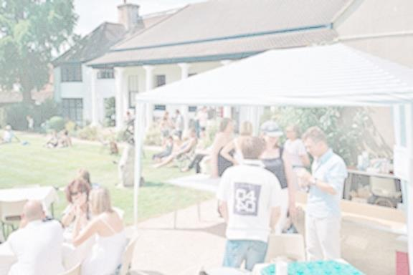

**BBQ, BAR, REFRESHMENTS, FACEPAINTING, CHILDRENS ACTIVITY TABLE**

**Admission Friday : £5  
 Admission Saturday: £5 Adult  
 £3 children 5 - 16  
 £8 weekend pass**

**Featuring local musicians:**

**Friday:, Spotlight Cannibal, Track of Words, Joe Mills, Water-shed, Will B.**

**Saturday: Jazz Morley, House Of Hats, Aimee, The Free Radicals, The Glory Boys, Luke Ferre, Leigh Mary Stokes, Louella and the Red Horizon, John Meriton,   
Liz Williams,Cardboard Carousel, Vic Cracknell, , Nina Scholfield, ‘ The Crosstown Trio’ Cordelia Gartside , Rosie Musgrove**

**ADVANCE TICKETS CONTACT MUSEUM ON 01428 642112  
ALSO AVAILABLE ON THE DOOR**

**Museum opening hours 10 am – 5pm**

**TUESDAY - SATURDAY**

Registered Office: 78 High Street, Haslemere, Surrey, GU272LA Charity No. 1071244

**HASLEMERE MUSEUM’S FOUNDER’S   
MUSIC FESTIVAL**

**FRIDAY 19 JULY – 7pm-11pm SATURDAY 20 JULY – 12-11pm**

